Wedding Fan Program Template

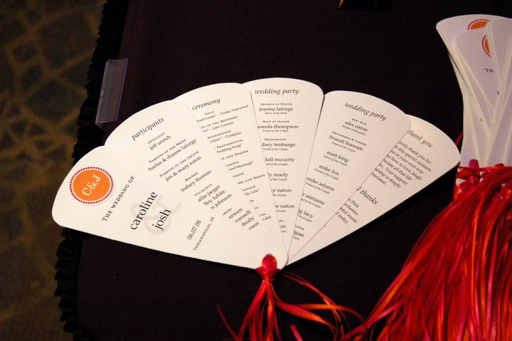

Instructions:
- Begin by editing the first blade on each page, until you have the design set.
- Next, copy the contents of the first blade to the two to the right of it on each page.
- Add or take away as many blades as you need for your unique wedding.
- Finally, print the document on heavy and/or glossy cardstock and carefully cut each blade out.
- Makes 3 programs per print.

This wedding program was created by Bubbly Bride (www.bubblybride.com), modified from designs by Aylee (www.ayleebits.com).


The wedding of



01.01.01

City, ST

participants

Officiant
first and last name

Parents of the Bride
parents names

Parents of the Groom
parents names

Reader
reader #1

Vocalists
vocalist #1
vocalist #2

Ushers
usher #1
usher #2
usher #3

ceremony

Solo
“Where Your Road Leads” Trisha Yearwood

Seating of the Mothers
“Love” John Lennon

Processional
“Amsterdam” Coldplay

Bridal Processional
“The Wedding Song”

Welcome and Prayer

Reading
“Art of a Good Marriage”

Message

Exchange Vows and Rings

Unity Candle
“Grace of My Life”

Prayer

Blessing

Recessional

wedding party

Matron of Honor
first and last name
Sister of the Bride

Maid of Honor
first and last name
Friend of the Couple

Bridesmaids
first and last name
Friend of the Couple

first and last name
Friend of the Couple

first and last name
Friend of the Couple

first and last name
Sister of the Groom

first and last name
Sister of the Groom

Flower Girl
first and last name
Cousin of the Groom

wedding party

Best Man
first and last name
Brother of the groom

Groomsmen & Ushers
first and last name
Friend of the Couple

first and last name
Friend of the Couple

first and last name
Friend of the Couple

first and last name
Friend of the Couple

first and last name
Friend of the Couple

first and last name
Friend of the Couple

Ring Bearer
first and last name
Friend of the Couple

thank you

We sincerely thank you for
joining us on this special occasion.
Each of you in your own way
has shown us how to love, laugh
and appreciate all that life
has to offer. Your support
and friendship is deeply
appreciated.

special thanks

To xxxxxx
and his orchestra
for the beautiful music
we enjoyed today.

J & C

